

COMPANY RATING WEBSITE

USER GUIDE

*Report #6*

|  |  |  |
| --- | --- | --- |
| **COMPANY RATING WEBSITE – *KẾ SINH NHAI TEAM*** | | |
| **Group Members** | Trần Quốc Hưng | SE02970 |
| Nguyễn Sơn Lâm | SE03090 |
| Nguyễn Việt Hùng | SE03293 |
| Nguyễn Nhật Quang | SE03122 |
| Trần Đăng | SE03039 |
| **Supervisor** | Bùi Đình Chiến | |
| **Project code** | CRW | |

**- Hanoi, 28/05/2016 -**

# SIGNATURE PAGE

**AUTHORS**: Nguyễn Sơn Lâm 16/08/2016

*Team member*

**REVIEWER**: Nguyễn Nhật Quang 16/08/2016

*Project Leader*

**APPROVAL**: Bùi Đình Chiến --/--/2016

*Supervisor*

# Record of change

*A – Added; M – Modified; D – Deleted

|  |  |  |  |  |  |
| --- | --- | --- | --- | --- | --- |
| Effective Date | Changed Item | A,M,D* | Change Description | Reason for Change | Rev. Number |
| 16/08/2016 | User Guide | A | First version | Create User Guide | 1.0 |
|  |  |  |  |  |  |
|  |  |  |  |  |  |

Table of Contents

SIGNATURE PAGE 2

Record of change 3

1. INTRODUCTION 5

1.1 Purpose 5

1.2 Viết tắt 5

2. INSTALLATION GUIDE 6

2.1. Register 6

2.2. Login 6

2.3. Logout 7

2.4. Recover password: 7

2.5. Discover company 8

2.5.1. Go to Company list page 8

2.5.2. Filter at Company list page 9

2.6. Search company 10

2.6.1. Search via search bar at header 10

2.6.2. Search via Company list page 10

2.7. Company details 11

2.7.1. Follow a company 11

2.7.2. Unfollow a company 12

2.8. Review Details 12

2.8.1. Comment 13

2.8.2. Delete comment 14

2.8.3. Upvote review 14

2.8.4. Remove upvote 15

2.8.5. Bookmark review 16

2.8.6. Remove bookmark 16

2.8.7. Report 17

2.9. Write review 18

2.9.1. Write review for an existed company 18

2.9.2. Write review for a new company 18

2.10. Account management 20

2.10.1. Account info 20

2.10.2. Notification 20

2.10.3. Posted review managemnt: 21

2.10.4. Bookmarked review managemnt: 22

2.10.5. Followed company list: 22

2.10.6. Edit account info 23

2.10.6.1. Update profile 24

2.10.6.2. Update avatar 24

2.10.6.3. Update password 25

2.10.7. Manage SNS account 25

2.11. Admin management 26

2.11.1. Pending review management 26

2.11.1.1. Approve a review 26

2.11.1.2. Reject a review 27

2.11.2. Report management 28

2.11.2.1. Accept report(s) 28

2.11.2.2. Reject report(s) 29

2.11.3. User management 30

2.11.3.1. Block/Unblock an user 31

2.11.3.2. Promote/demote an user/mod 33

2.11.4. Company management 34

# INTRODUCTION

## Purpose

This user's manual has been developed to help users better understand the requirements that may apply to use this website by providing them simple step by step tutorials. This manual is intended to help make website's functions more accessible and their associated requirements more understandable to users.

## Viết tắt

|  |  |  |
| --- | --- | --- |
| Từ | Ý nghĩa | Chú thích |
| CRW | Company Rating Website | Tên dự án. |
| SNS | Social Network Service |  |
| Người dùng | Khách, thành viên và quản trị viên |  |
| NDC | Người dùng chính | Thành viên và quản trị viên, là những người đóng góp nội dung trong website |
| QTV | Quản trị viên |  |
| URL | Uniform Resource Locator | Đường dẫn của trang web |

# INSTALLATION GUIDE

## Register

To register account on website, you should follow these steps:

Step 1: Open browser and enter to the address bar: <http://companyrating.xyz/>. Homepage is displayed.

Step 2: Click on “Đăng nhập” button in header. Then click “Chưa có tài khoản? Đăng ký ngay!” hyperlink, you will be redirected to Register page.

Step 3: Enter information and click on “Đăng ký” button or you can register by choose “Đăng nhập với Facebook”.

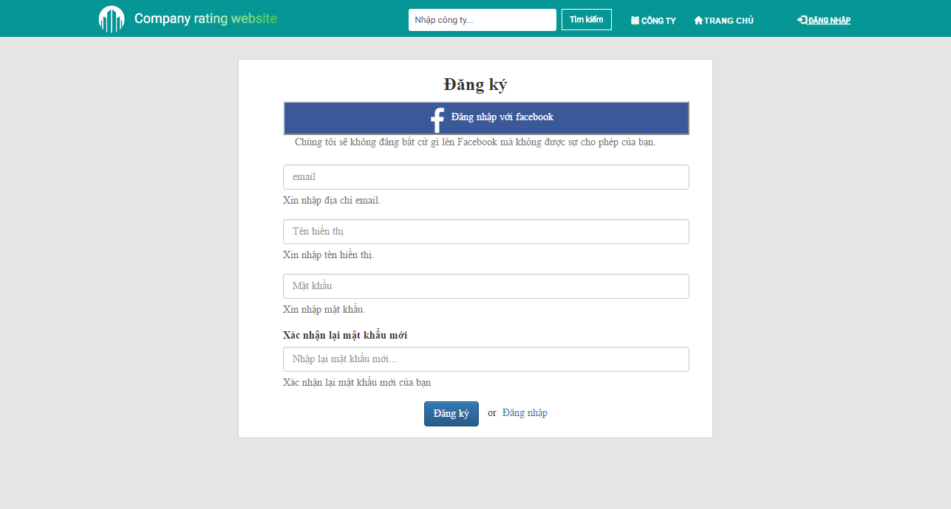

1. Register scren

## Login

To login account on website, you should follow these steps:

Step 1: Open browser and enter to the address bar: <http://companyrating.xyz/>. Homepage is displayed.

Step 2: Click on Đăng nhập button in header. You will be redirected to Login page.

Step 3: You can choose login with account or login with Facebook.

Step 3.1: If you choose login with account, you can enter username and password and click “Đăng nhập” button.

Step 3.2: If you choose login with Facebool, you can click “Đăng nhập với Facebook” button.

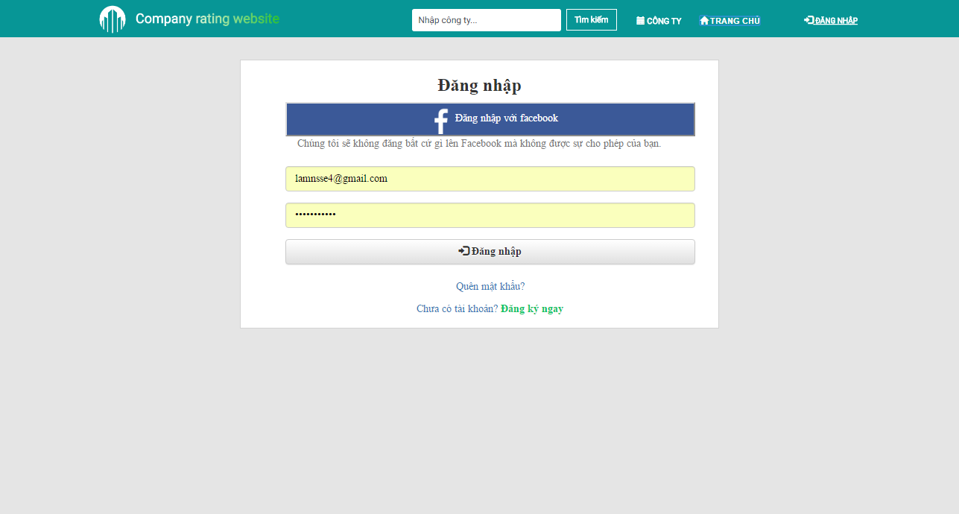

1. Login page

## Logout

To logout, you should follow these steps:

Step 1: Click on user avatar at upper-left of screen.

Step 2: Click on “Đăng xuất” button at dropdown menu.

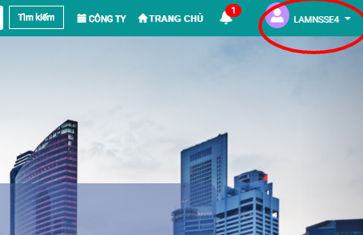

1. Log out

## Recover password:

If user forgot account password and can’t login, user can follow these steps to recover password:

Step 1: Go to Homepage, click “Đăng nhập button”.

Step 2: Click “Quên mật khẩu” hyperlink.

Step 3: Type account email into textbox and click “Xác nhận”.

Step 4: Check account email to get new password.

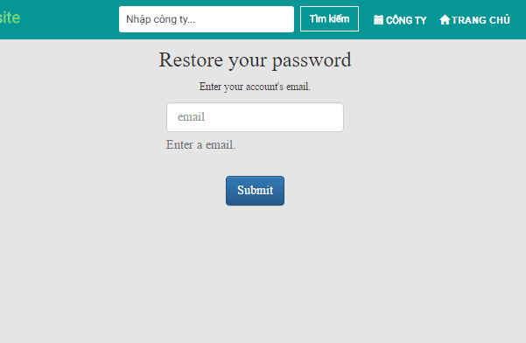

1. Recover password

## Discover company

## Go to Company list page

Company list page is the page that user can view all companies, number of reviews of each company, average score of each company, highlighted companies… To go to Company list page, the user do the steps below:

Step 1: Go to Homepage.

Step 2: Click on “Công ty” button in header. Company list page will be displayed.

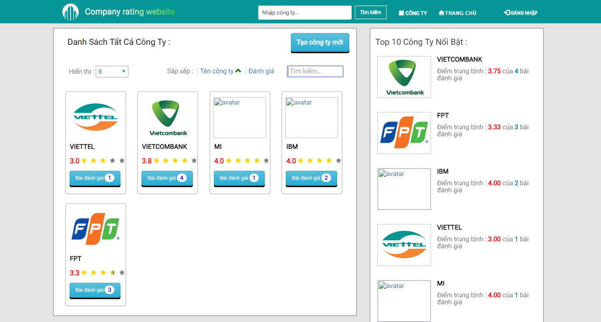

1. Company list page

## Filter at Company list page

You can filter at Company list page by many criteria: average score, company name, number of reviews.

To filter at Company list page, you should follow these steps:

Step 1: Go to Company list page.

Step 2: Click on “Tên công ty” or “Đánh giá” filter.

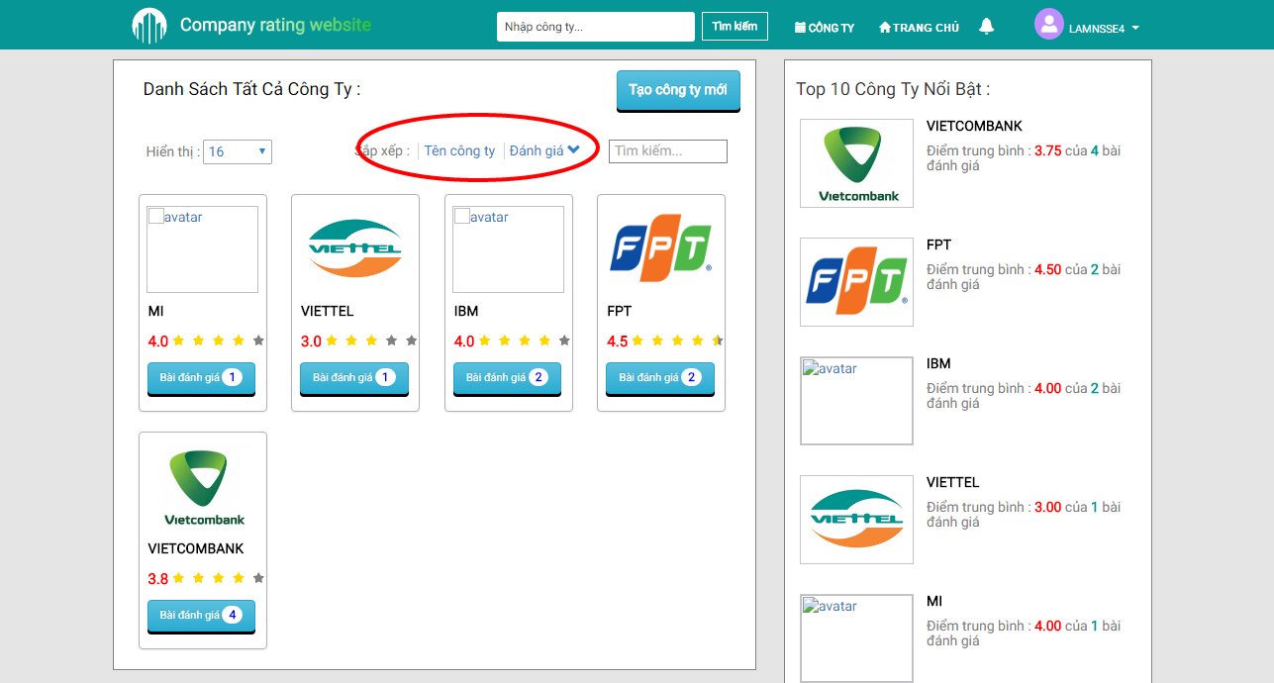

1. Filter at Company list page

## Search company

CRW provides 2 options to search company: Use search bar at header or Use search textbox at Company list page.

## Search via search bar at header

Step 1: Go to Homepage.

Step 2: Type company name into search bar at header, then press Enter or click “Tìm kiếm” button.

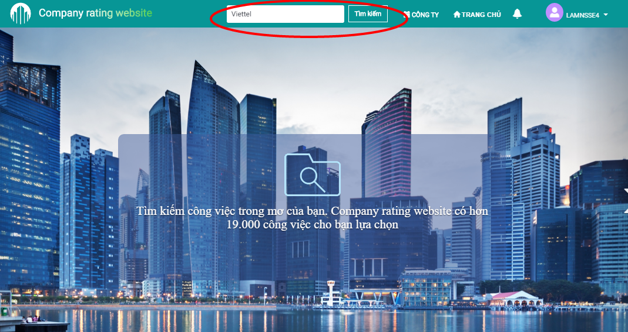

1. Seach at header

## Search via Company list page

Step 1: Go to Company list page.

Step 2: Type company name into search textbox at Company list page. Result will be displayed in real-time.

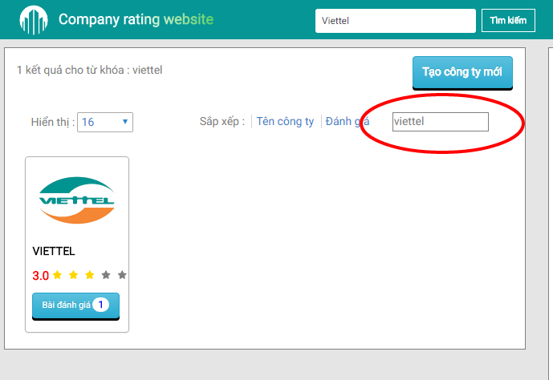

1. Search via Company list page

## Company details

In this page, user can view company details and its review list, follow company, write review for that company. You can view a company details page by following these steps:

Step 1: Go to Company list page.

Step 2: Click to a company that you want to view details page.

## Follow a company

If user follows a company, system will send notification to user when that company has a new review.

Step 1: Go to Company list page, click to company you want to follow (i.e FPT).

Step 2: Click “Theo dõi” button at banner of company, click OK at comfirmation popup.

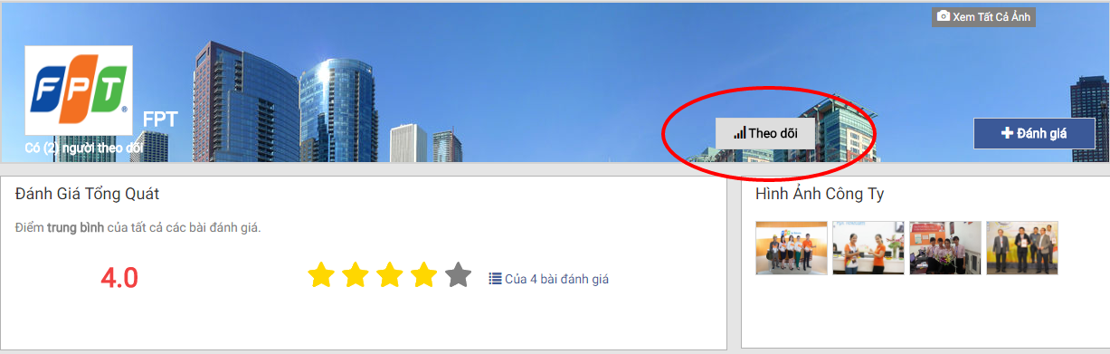

1. Follow a company

## Unfollow a company

If you are following a company but want to stop receiving notification, you can unfollow that company by doing these steps:

Step 1: Go to Company list page, click to company you want to unfollow (i.e FPT).

Step 2: Click “Bỏ theo dõi” button at banner of company, click OK at comfirmation popup.

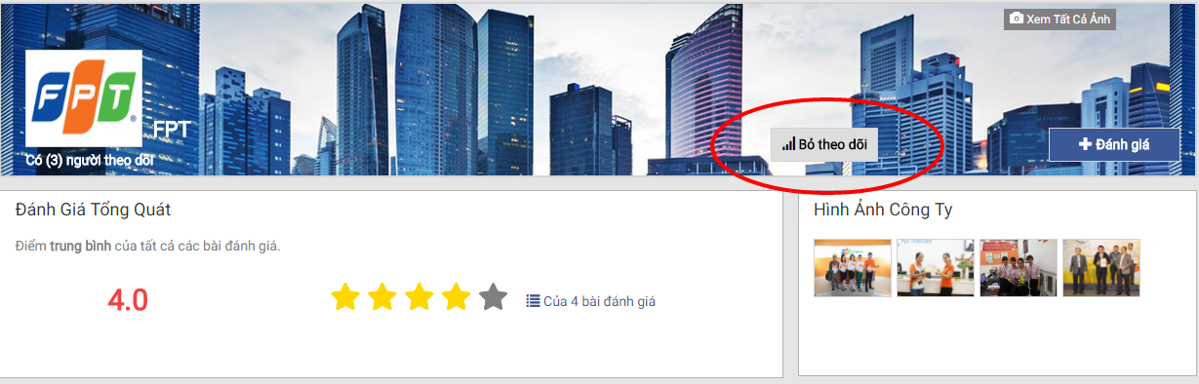

1. Unfollow a company

## Review Details

In a review details page, you can view, upvote, bookmark, comment on or report that review. To go to review details page, you should follow these steps:

Step 1: Go to Company list page, click to company that you want to read its reviews (i.e IBM).

Step 2: Click review you want to read. Review details page will be displayed.

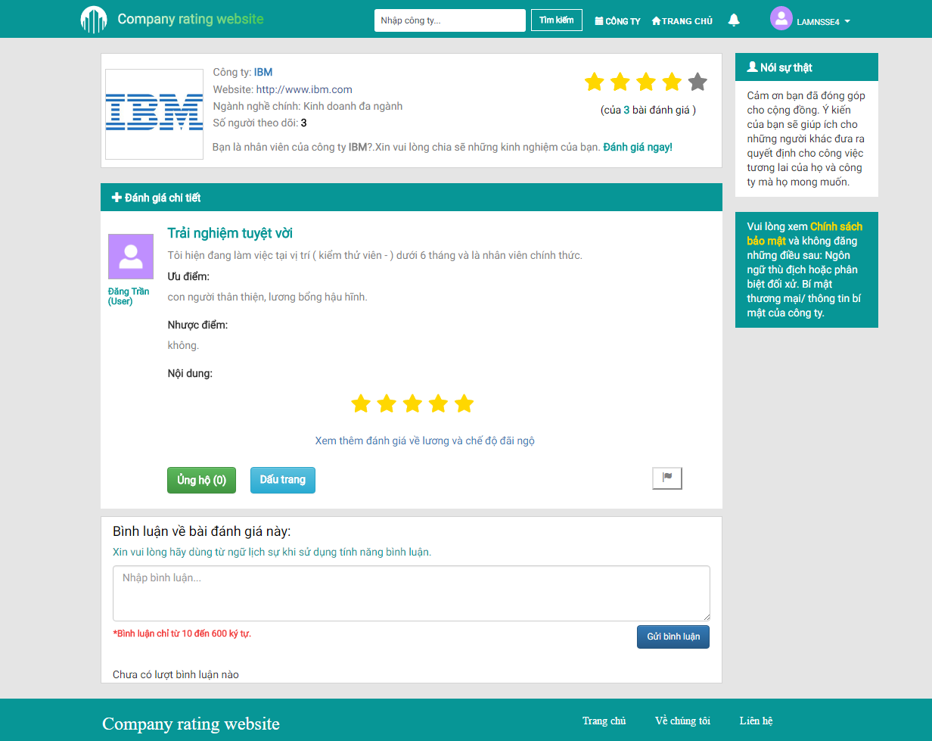

1. Review details page

## Comment

You can comment on a review by following these steps:

Step 1: Go to Review details page.

Step 2: Type comment into comment textbox and click “Gửi bình luận” button.

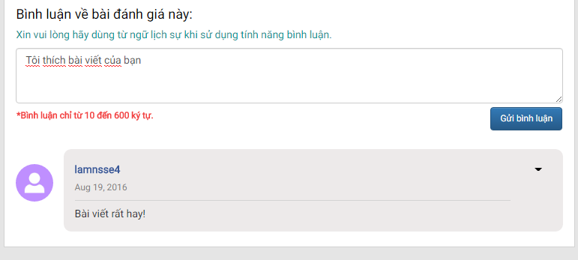

1. Comment

## Delete comment

If you want to delete your comment, you can follow these steps:

Step 1: Go to Review details page that has your comment.

Step 2: Click to triangle button at upper-right corner of your comment, then click “Xóa” button.

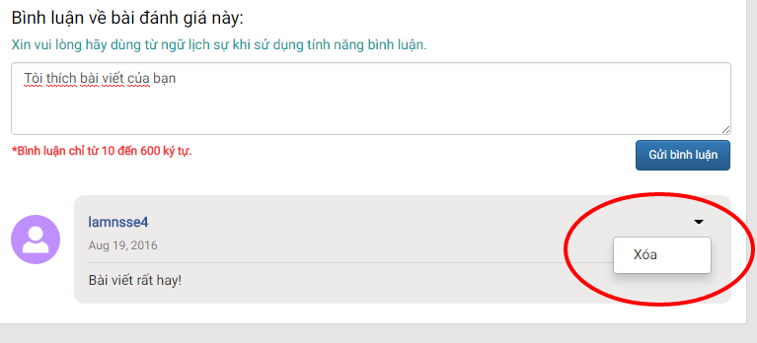

1. Delete comment

## Upvote review

If you want to show your support to a review, you can upvote that review. To upvote a review, you should follow these steps:

Step 1: Go to Review details page.

Step 2: Click “Ủng hộ” button under the review, then click “Xác nhận” button.

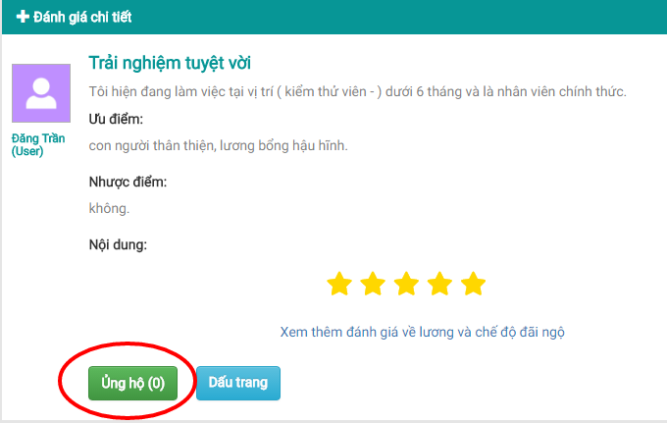

1. Upvote

## Remove upvote

To remove upvote from a review, you should follow these steps:

Step 1: Go to Review details page that has your upvote.

Step 2: Click “Bỏ ủng hộ” button under the review, then click “Xác nhận” button.

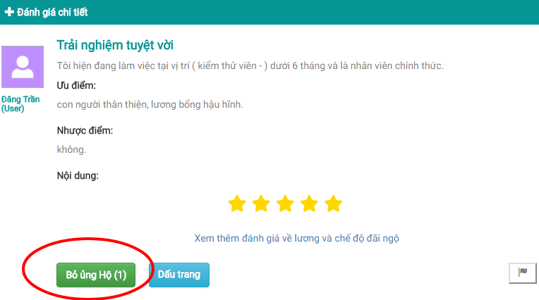

1. Remove upvote

## Bookmark review

You can bookmark a review to read it later. To bookmark a review, you should follow these steps:

Step 1: Go to Review details page.

Step 2: Click “Dấu trang” button under the review.

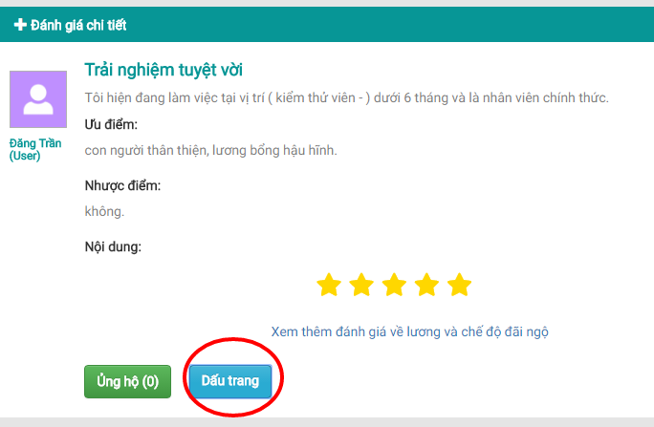

1. Bookmark review

## Remove bookmark

To remove a bookmark, you should follow these steps:

Step 1: Go to Review details page that you’ve bookmarked.

Step 2: Click “Bỏ lưu dấu trang” button under the review.

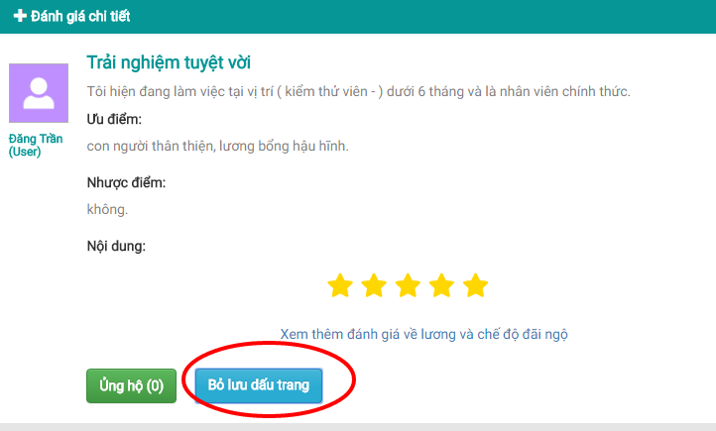

1. Remove bookmark

## Report

If you want to report a review (hate speech, malicious content…) to mod, admin, you should follow these steps:

Step 1: Go to Review details page that you want to report.

Step 2: Click “Báo cáo” button under the review.

Step 3: Type your report into textbox, then click “Hoàn thành” button.

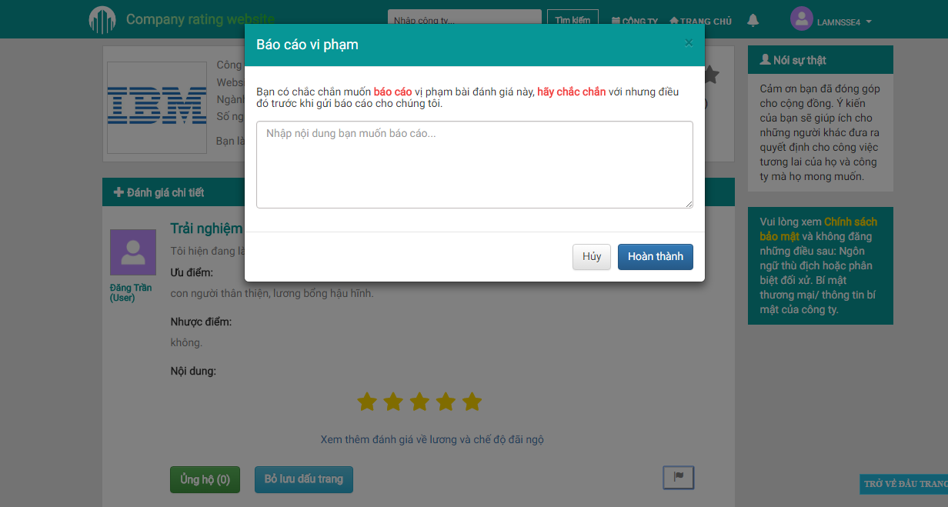

## Write review

You can share your experience with your company by writing a review. You have 2 options: Write review for an existed company or Write review for a new company.

**Note:** All reviews will be checked by mod/admin. Your review will be displayed on website if mod/admin approves that review. On the contrary, if mod/admin reject your review, you must edit then resend it for approving again.

## Write review for an existed company

Step 1: Go to Company list page, click to company you want to write review for (i.e FPT).

Step 2: Click “Đánh giá” button at banner of company.

Step 3: Fill in all nescessary fields in Create review page.

Step 4: Click “Gửi đánh giá” button.

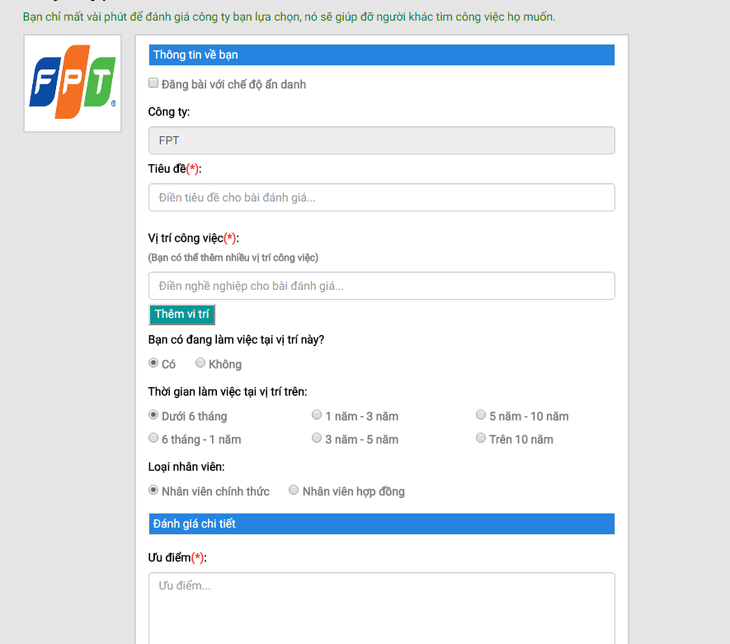

1. Write review for an existed company

## Write review for a new company

Step 1: Go to Company list page, click “Thêm công ty” button.

Step 2: Fill in all nescessary fields in Create company page. Click “Tạo công ty” button.

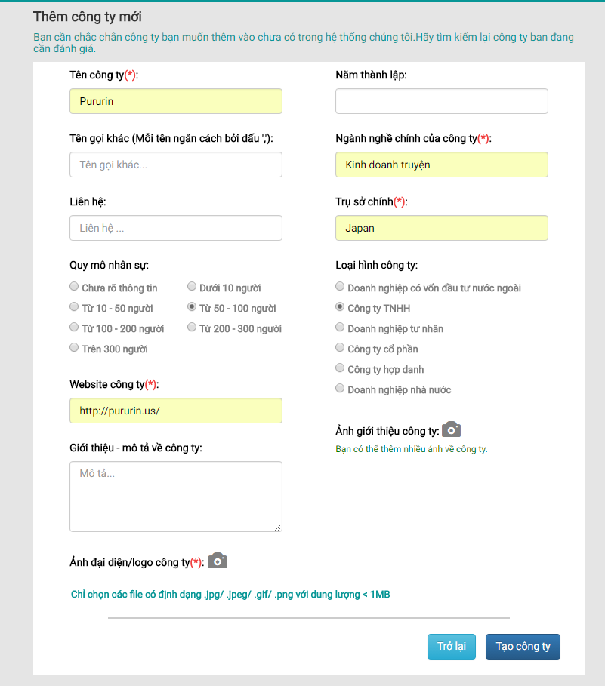

1. Create company page

Step 3: You will be redirected to the Create review page of the new company. Fill in all nescessary fields and click “Gửi đánh giá” button.

## Account management

## Account info

User can view his public profile by following these steps:

Step 1: Login with user’s account.

Step 2: Click on user avatar, then click “Quản trị tài khoản” hyperlink.

Step 3: Click on “Thông tin tài khoản” tab at side menu

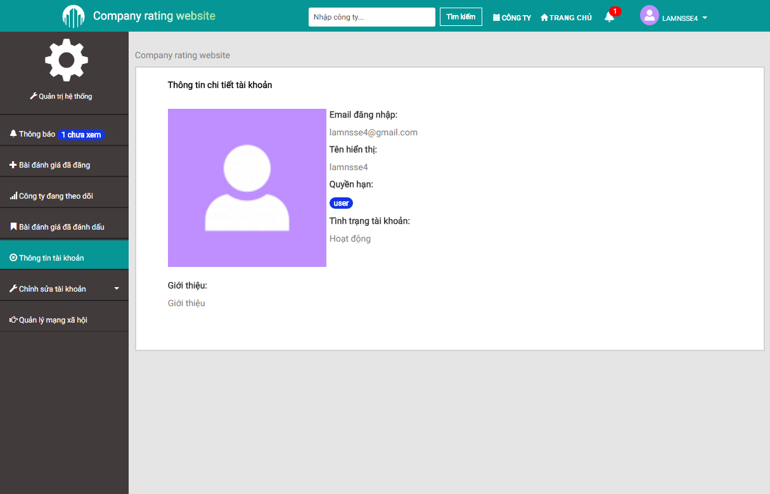

1. Account Info

## Notification

User will receive notification from CRW when user’s review is approved, user’s followed company has new review… To manage notification, user should follow these steps:

Step 1: Login with user’s account.

Step 2: Click to bell icon at the header.

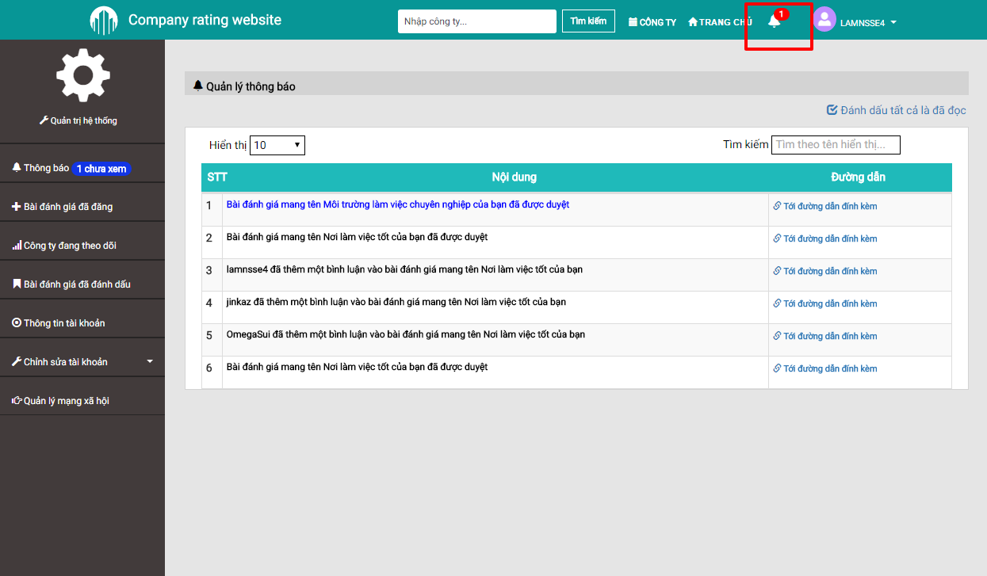

1. Notification

## Posted review managemnt:

You can manage your posted review(s) by following these steps:

Step 1: Login with your account.

Step 2: Click at user avatar, then click “Quản trị tài khoản” hyperlink.

Step 3: Click at “Bài đánh giá đã đăng” tab.

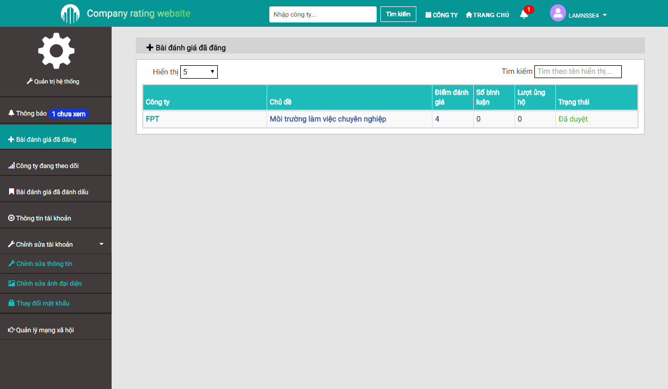

1. Posted review management

## Bookmarked review managemnt:

You can manage your bookmarked review(s) by following these steps:

Step 1: Go to “Quản trị tài khoản” page

Step 2: Click at “Bài đánh giá đã đánh dấu” tab.

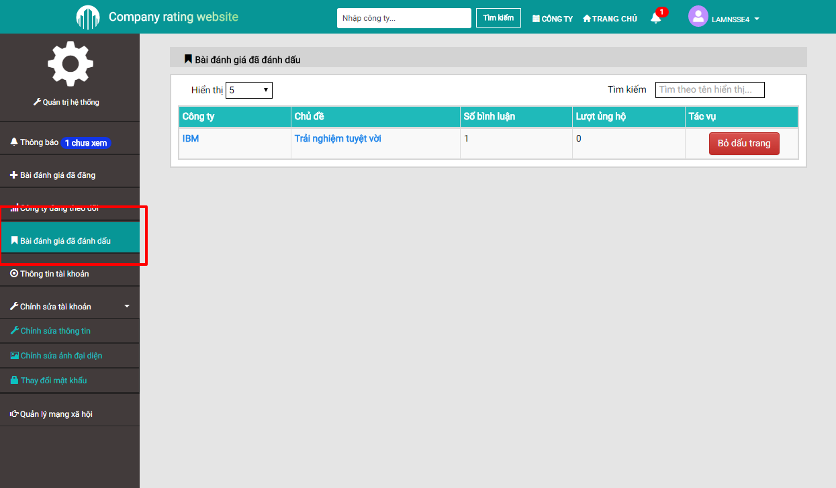

1. Bookmarked review management

## Followed company list:

You can manage your followed company list following these steps:

Step 1: Go to “Quản trị tài khoản” page

Step 2: Click at “Công ty đang theo dõi” tab.

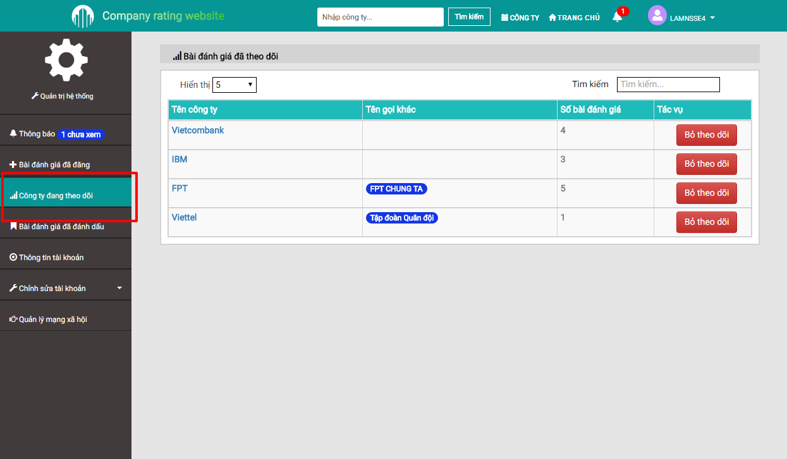

1. Followed company list

## Edit account info

User can edit account info by following these steps:

Step 1: Go to “Quản trị tài khoản” page

Step 2: Click at “Chỉnh sửa thông tin tài khoản” tab at side menu.

## Update profile

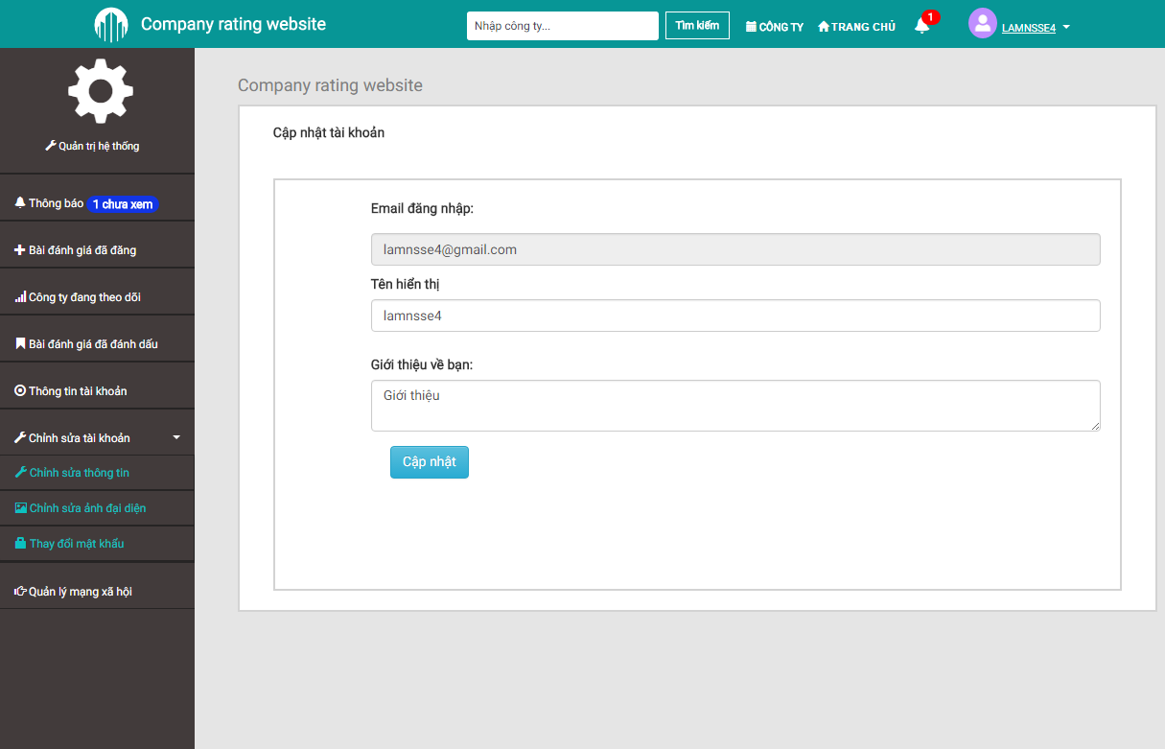

1. Update profile

## Update avatar

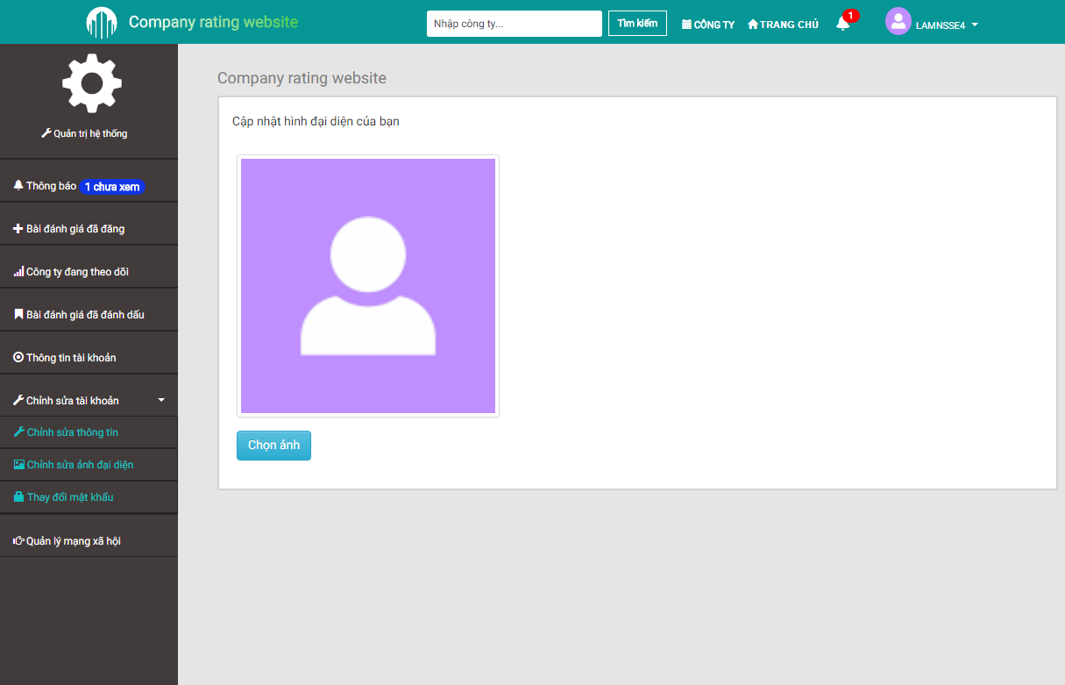

1. Update avatar

## Update password

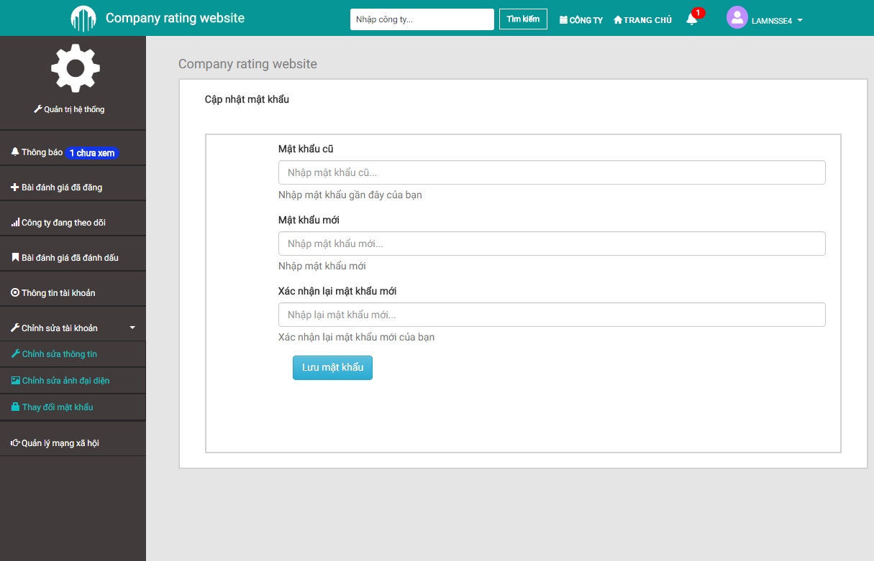

1. Update password

## Manage SNS account

User can manage SNS accounts that are used to login to CRW. To manage SNS account, user should follow these steps:

Step 1: Go to “Quản trị tài khoản” page

Step 2: Click at “Quản lý tài khoản mạng xã hội” tab at side menu.

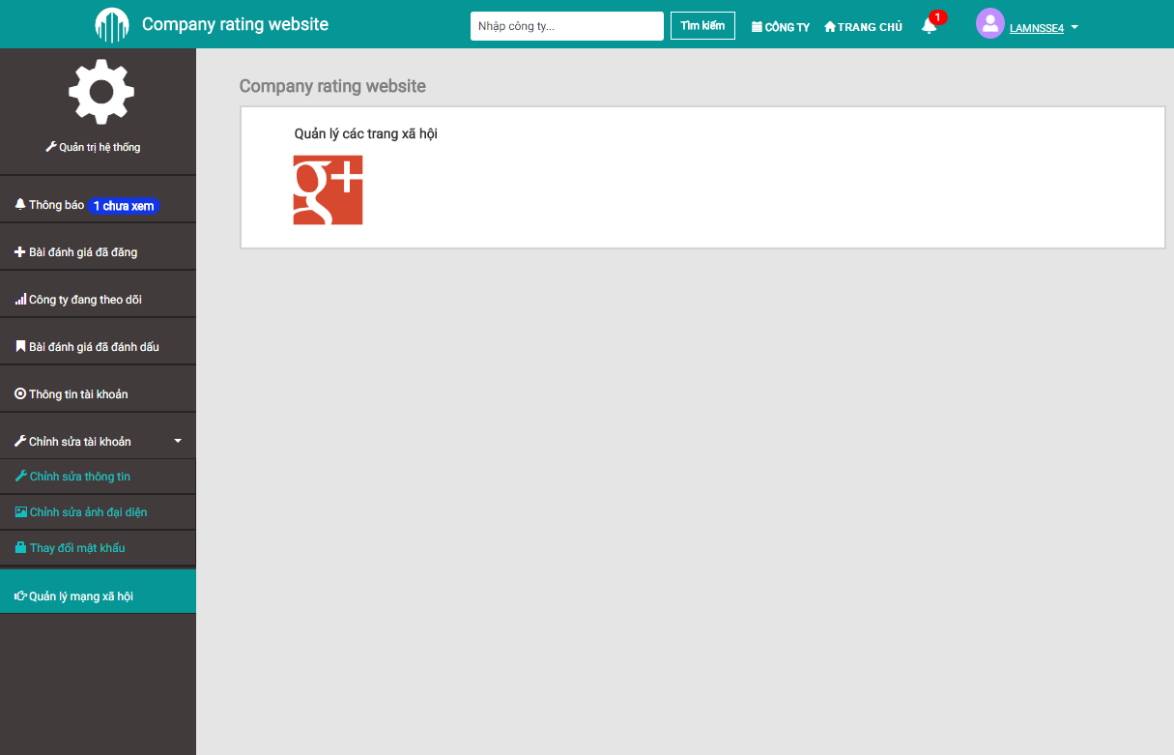

1. Manage SNS account

## Admin management

This group of function is only available to mod/admin.

## Pending review management

Admin can approve reviews that are sent from users to display them on web site, or reject bad reviews.

## Approve a review

To approve a review, admin should follow these steps:

Step 1: Login with admin account

Step 2: Go to “Quản trị tài khoản” page

Step 3: Click at “Xử lý bài đăng” tab at side menu.

Step 4: Click to the review admin want to approve at “Bài đánh giá chờ duyệt” tab.

Step 5: Click “Duyệt bài” button, then click “Xác nhận” button.

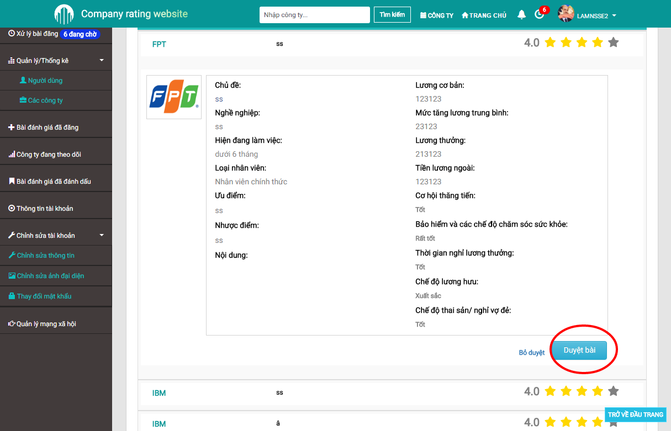

1. Approve a review

## Reject a review

To reject a review, admin should follow these steps:

Step 1: Login with admin account

Step 2: Go to “Quản trị tài khoản” page

Step 3: Click at “Xử lý bài đăng” tab at side menu.

Step 4: Click to the review admin want to reject at “Bài đánh giá chờ duyệt” tab.

Step 5: Click “Bỏ duyệt” button, then type into textbox the rejection reason and click “Xác nhận” button.

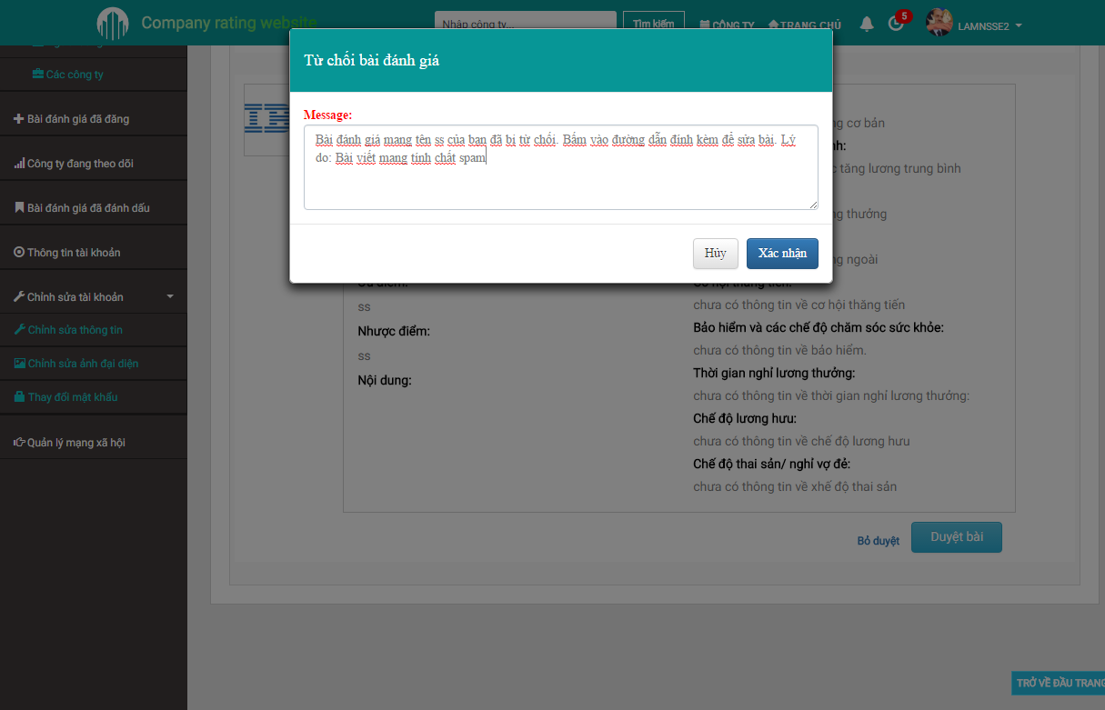

1. Reject a review

## Report management

## Accept report(s)

To accept a report, admin should follow these steps:

Step 1: Login with admin account

Step 2: Go to “Quản trị tài khoản” page

Step 3: Click at “Xử lý bài đăng” tab at side menu.

Step 4: Click to the review admin want to accept reports at “Bài cáo chờ xử lý” tab.

Step 5: Click “Xử lý” button, then type into textbox the reason and click “Xác nhận” button.

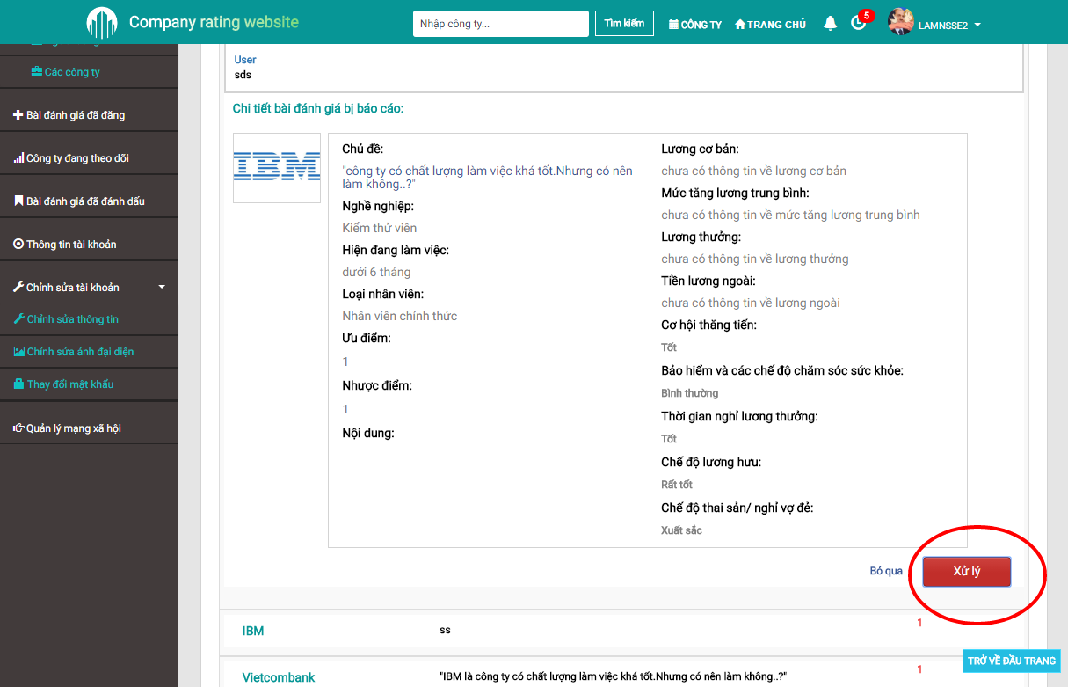

1. Approve report(s)

## Reject report(s)

To reject a report, admin should follow these steps:

Step 1: Login with admin account

Step 2: Go to “Quản trị tài khoản” page

Step 3: Click at “Xử lý bài đăng” tab at side menu.

Step 4: Click to the review admin want to rejct reports at “Bài cáo chờ xử lý” tab.

Step 5: Click “Bỏ qua” button, then click “Xác nhận” button.

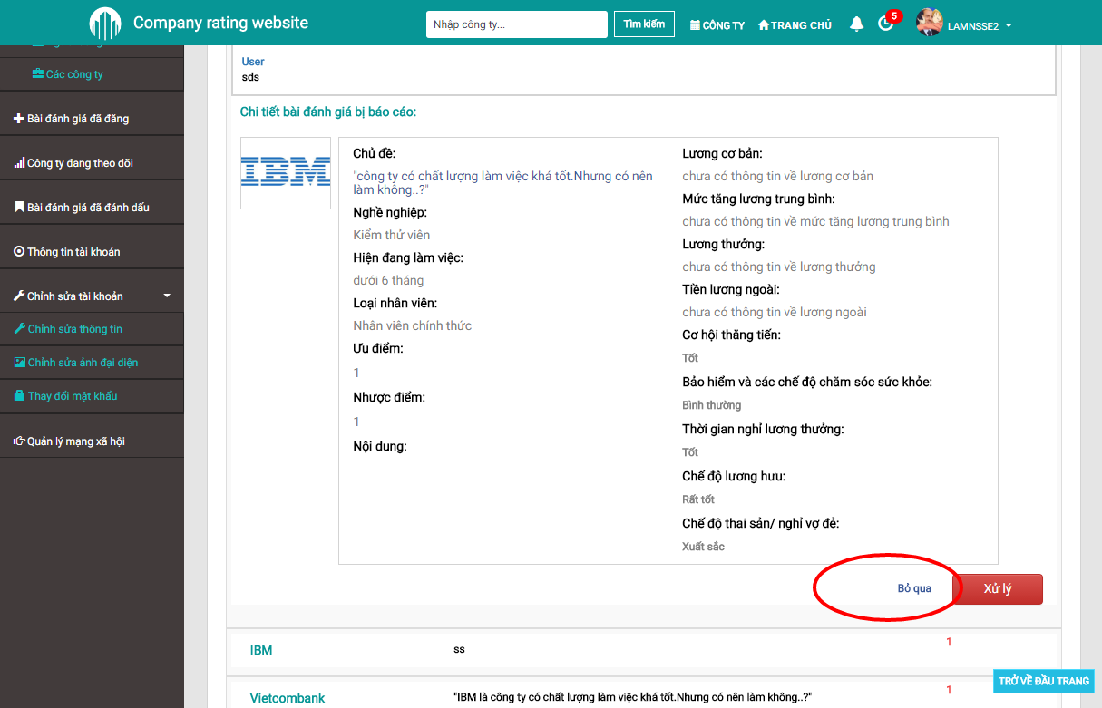

1. Reject report(s)

## User management

Admin can view all users and their status at User management page. To access this page, admin should follow these steps:

Step 1: Login with admin account

Step 2: Go to “Quản trị tài khoản” page

Step 3: Click at “Quản lý/Thống kê” then “Người dùng” tab at side menu.

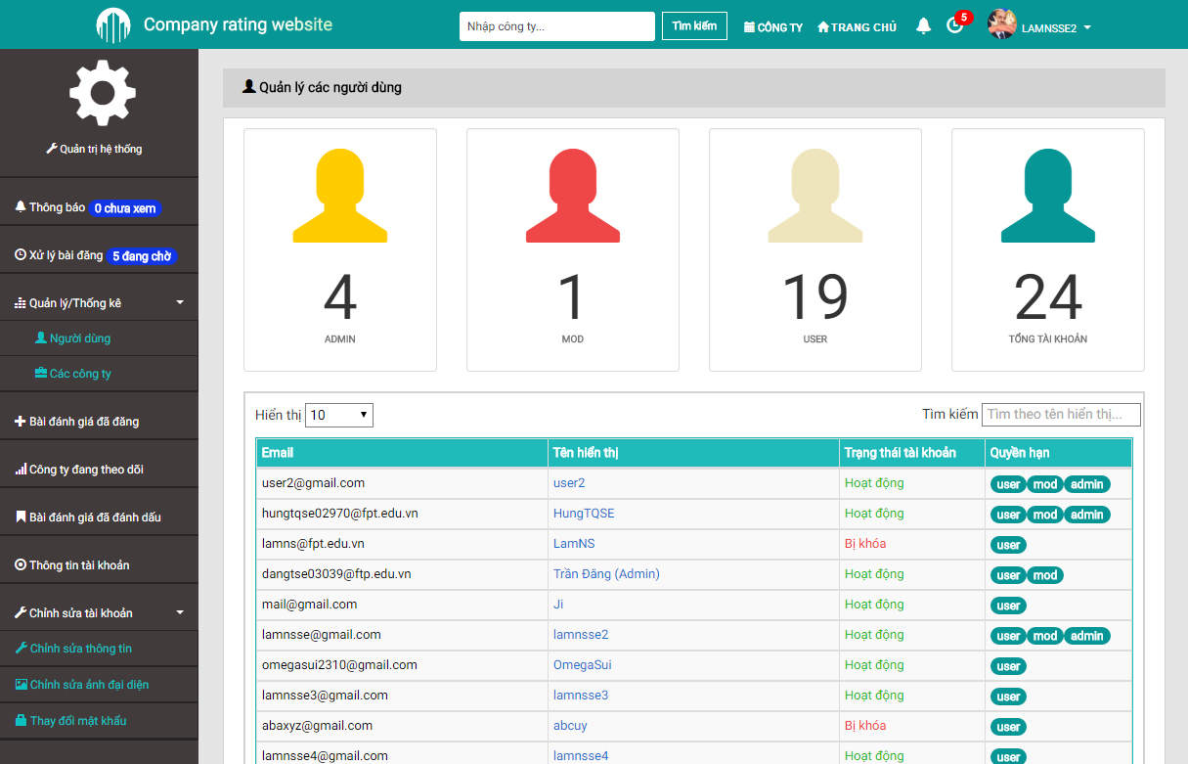

1. User management

## Block/Unblock an user

Step 1: Go to User management page.

Step 2: Click to the user needed to block/unblock.

Step 3: Click to “Khóa”/“Mở khóa” button.

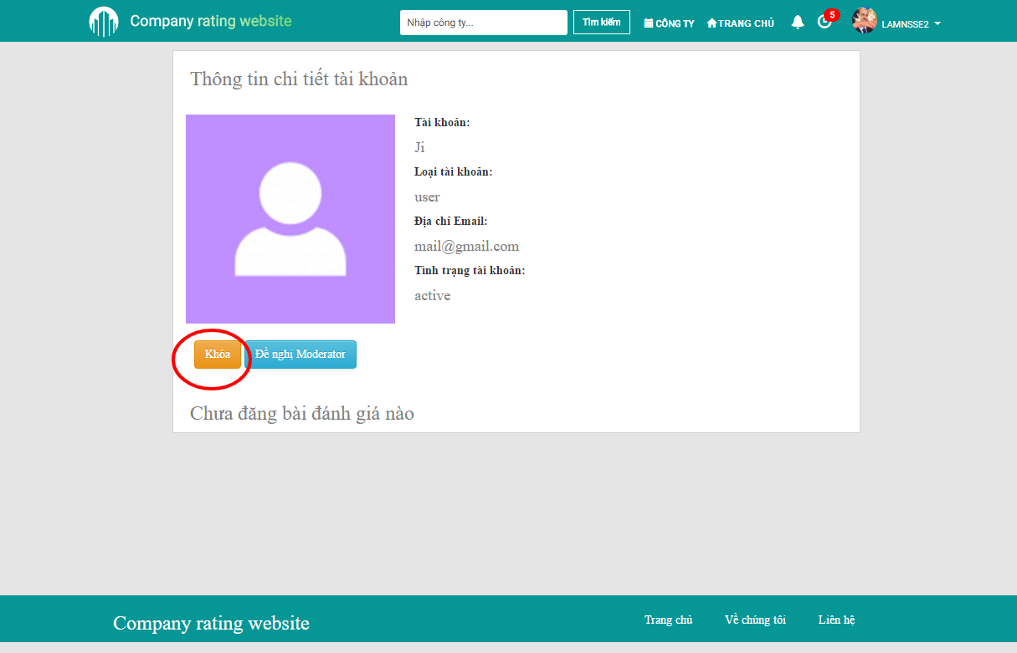

1. Block an user

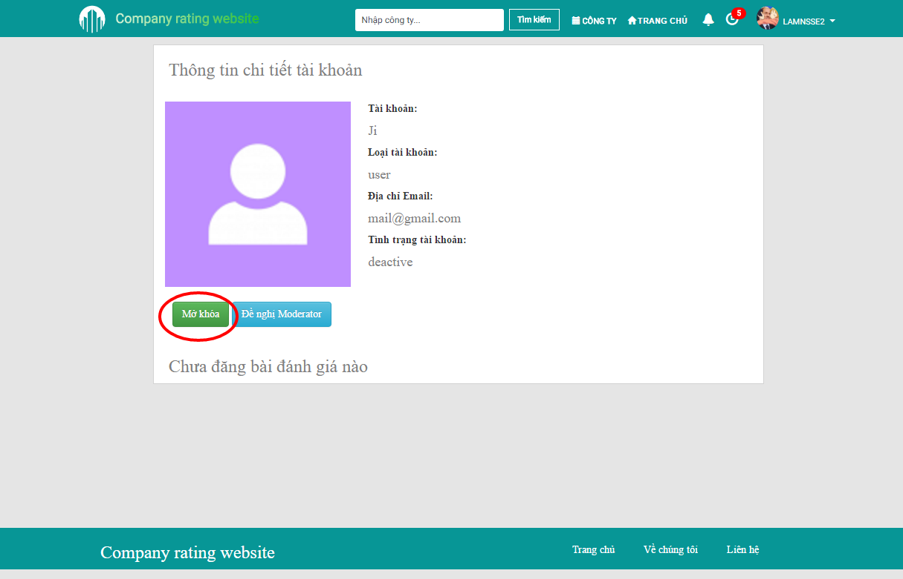

1. Unblock an user

## Promote/demote an user/mod

Step 1: Go to User management page.

Step 2: Click to the user/mod needed to promote/demote.

Step 3: Click to “Đề nghị Moderator”/“Hủy Moderator” button.

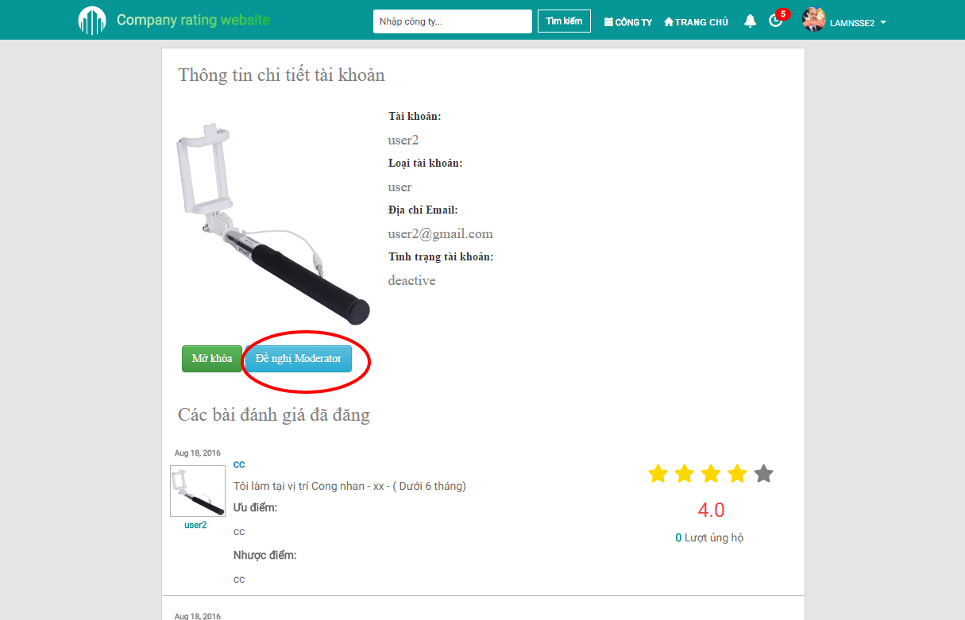

1. Promote an user

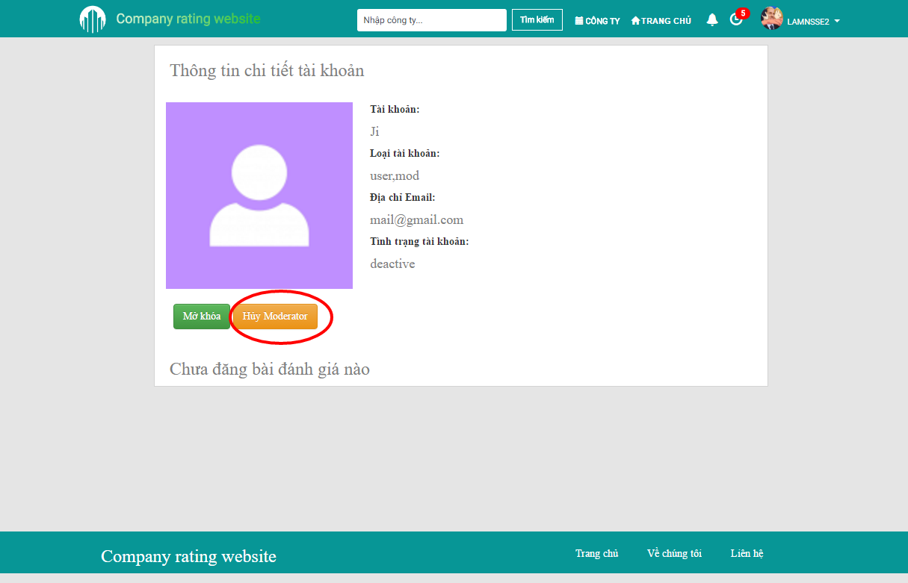

1. Demote an moderator

## Company management

Admin can view all companies and their status at Company management page. To access this page, admin should follow these steps:

Step 1: Login with admin account

Step 2: Go to “Quản trị tài khoản” page

Step 3: Click at “Quản lý/Thống kê” then “Công ty” tab at side menu.

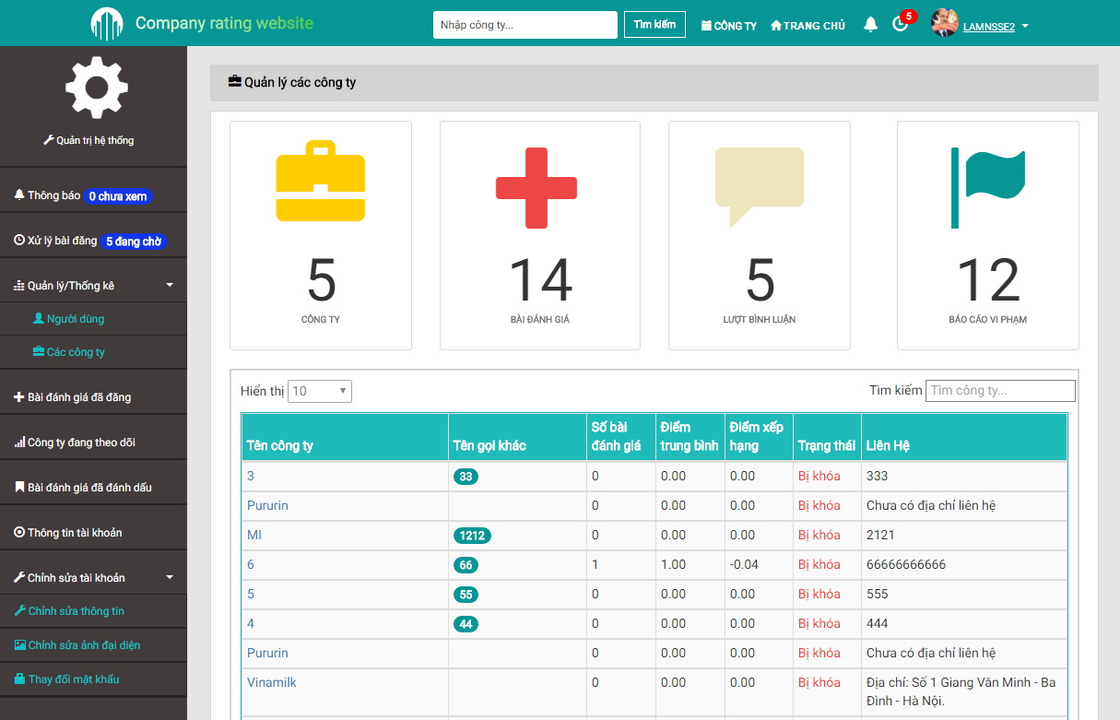

1. Company management